FACULTY OF INFORMATION TECHNOLOGY
IT PROJECT 700 | GROUP 55

EMERGEX
  - Centralized Student Accommodation & Secure Booking Application
PHASE 4 - SYSTEM DESIGN
Architecture, database, program, interface, security and test design
Supervisor: Thabiso | ThabisoA@richfield.ac.za | Semester 2, 2026
Student no. | Member | Email | Contact | Primary role
402308936 | Tristan Moses | 402308936@my.richfield.ac.za | 0828015082 | Project manager and frontend lead
402411668 | Reenesh Ramawthar | 402411668@my.richfield.ac.za | 0846041521 | Backend and quality engineering
402411227 | Joyce Kamalu | 402411227@my.richfield.ac.za | 0671075365 | Business analysis and documentation
402412304 | Novithan Naidoo | 402412304@my.richfield.ac.za | 0620829186 | Database and backend engineering
402413409 | Thingo Shezi | 402413409@my.richfield.ac.za | 0714299251 | UI/UX and frontend engineering
402111846 | Lungelo Ngwane | 402111846@my.richfield.ac.za | 0642534563 | Testing, deployment and support
Project lead baseline: Tristan Moses | Every member contributes and presents.

Table of Contents
System Design Phase 4
Description of the Proposed System 4
Architectural Design 5
Hardware and Network Architecture 6
Class and Behaviour Design 7
Physical and Database Design 8
Normalization 10
Program Design and Pseudocode 10
Interface Design 11
Input Validation Design 11
Output and Report Design 12
Security and Backup Design 12
Design Test Cases 13
References 14

PHASE 4

System Design Phase
The design translates validated requirements into modular software, data, interface, network, security and test structures.

Description of the Proposed System
EMERGEX is designed as a server-rendered, three-tier web application. Public pages offer search, property comparison and safety guidance. Protected pages form three role workspaces. The design favours explicit pages and shared security helpers over a complex framework so that the academic team can trace every form action to a query, rule and test. The database remains the source of truth for identity, ownership, availability, booking state, simulated escrow and audit evidence.
Table 1. Module decomposition
Module | Responsibilities | Primary data
Bootstrap and security services | Configuration, PDO connection, session policy, headers, escaping, CSRF, authorization, audit and utilities | Configuration, users, audit_logs
Identity | Student/landlord registration, login, logout and account status | users
Discovery | Published property query, search filters, property details and visual evidence | properties, users
Booking | Standard/instant request, response deadline, landlord decision and student status | bookings, properties, users
Escrow simulator | Create transaction, hold, release and reference generation | escrow_transactions, bookings
Document review | Validated upload, administrator approval/rejection and retention status | user_documents, users
Administration | Verification queues, metrics and audit monitoring | users, properties, documents, bookings, audit_logs
Presentation assets | Responsive layout, accessible navigation, local illustrations and status treatments | CSS, JavaScript, SVG assets

Architectural Design
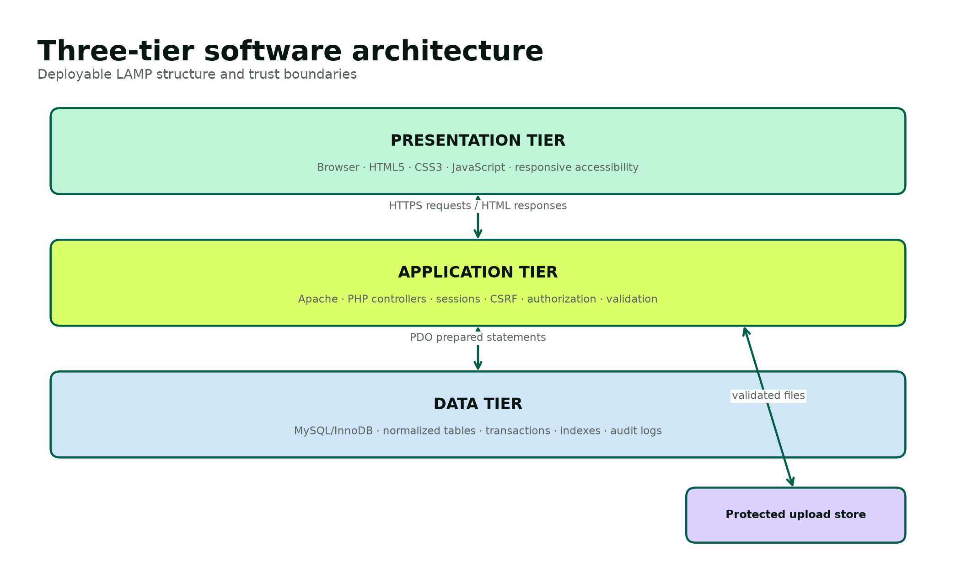
Figure 1. Three-tier LAMP software architecture.
The browser tier sends HTTPS requests and receives complete HTML responses. JavaScript is progressive enhancement for navigation and role-specific field visibility; business rules never depend on client-side code. The application tier validates requests, checks permissions and performs prepared SQL through PDO. The data tier uses InnoDB transactions and foreign keys. Uploaded demo files are stored under a protected directory with random file names, while metadata and review state remain in MySQL.
Table 2. Architecture decisions
Decision | Reason | Consequence
Server-rendered PHP pages | Minimizes build tooling and matches XAMPP teaching environment. | Simple deployment; page controllers must consistently call shared helpers.
Single bootstrap include | Centralizes security headers, sessions, database access and authorization. | One reviewed implementation controls all pages.
Native prepared statements | Separates SQL structure from user values [8]. | Reduced SQL injection exposure and clearer parameter tracing.
Database transactions for multi-record changes | Booking and escrow state must not diverge. | Failure rolls back both updates.
Local SVG illustrations | Demo remains visually complete without external image calls. | Images are representative, not evidence of real properties.
No real payment integration | Avoids unsafe or misleading financial functionality. | Escrow demonstrates state and audit only.
Minimal dependencies | Improves portability and auditability for the student team. | Some framework conveniences are implemented explicitly.

Hardware and Network Architecture
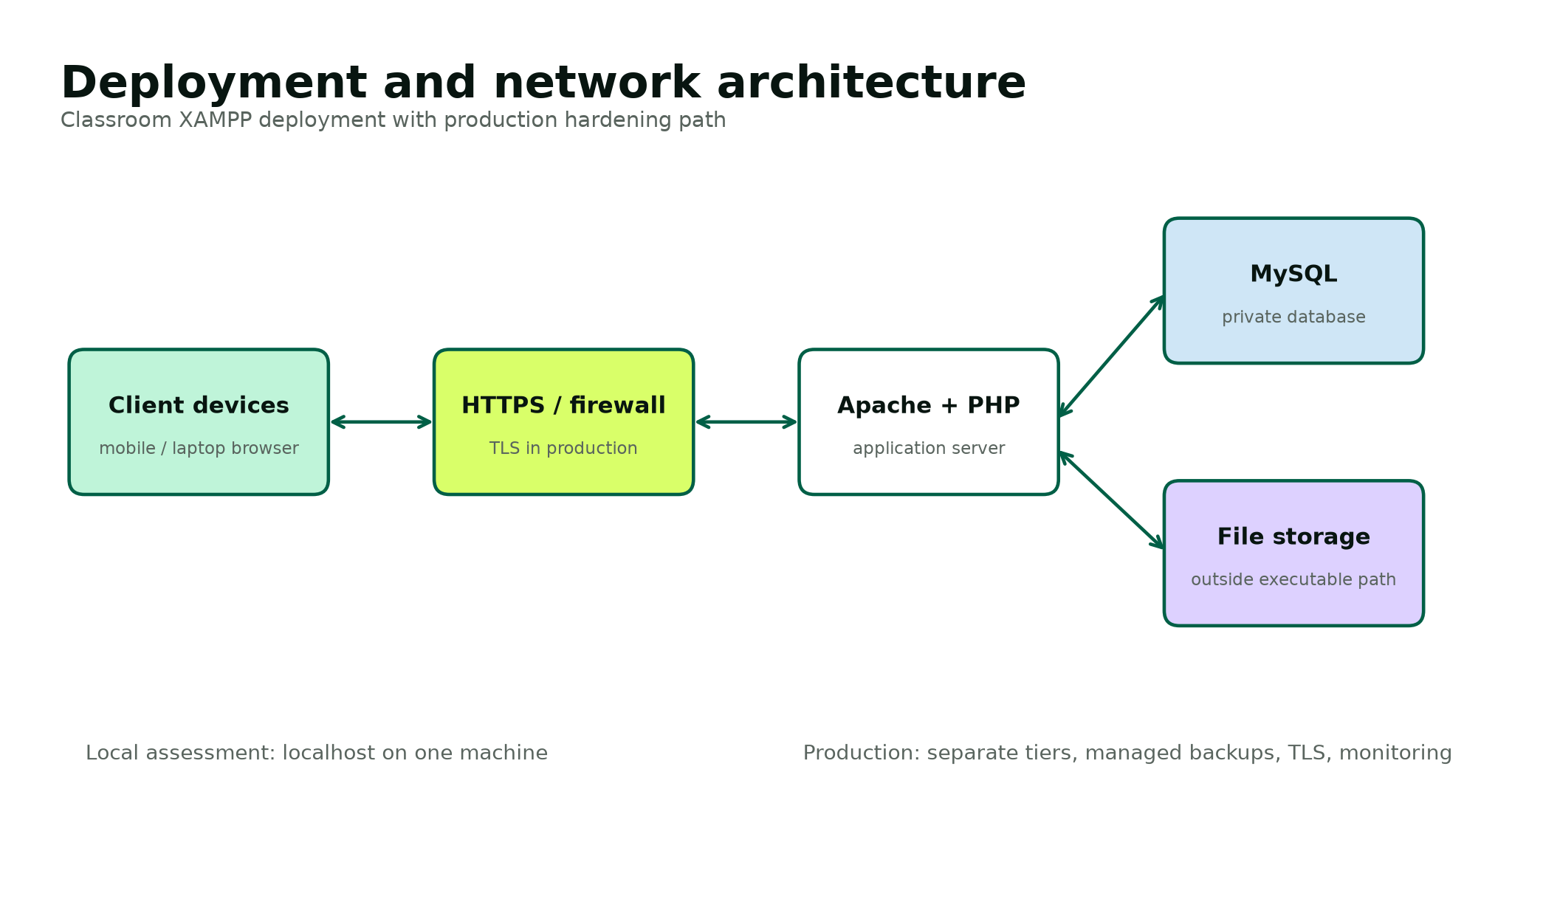
Figure 2. Deployment and network architecture.
Table 3. Deployment requirements
Environment | Minimum / proposed specification | Purpose
Developer workstation | Dual-core 64-bit processor, 8 GB RAM, 2 GB free disk, Windows 10/11 | Local coding, XAMPP, Word documentation and browser testing.
Assessment host | PHP 8.1+, Apache 2.4+, MySQL/MariaDB, Fileinfo and PDO MySQL | Runs the seeded offline demonstration.
Client | Current Chrome, Edge or Firefox; 360 px minimum viewport | Student, landlord and administrator interaction.
Production application tier | Hardened Linux host or managed container, TLS, WAF, monitoring and least-privilege service account | Future secure public service.
Production database tier | Private managed MySQL, encryption, point-in-time backups and restricted network access | Future durable data and recovery.
Backup storage | Encrypted, access-controlled and geographically separate | Future recovery evidence and retention enforcement.

Class and Behaviour Design
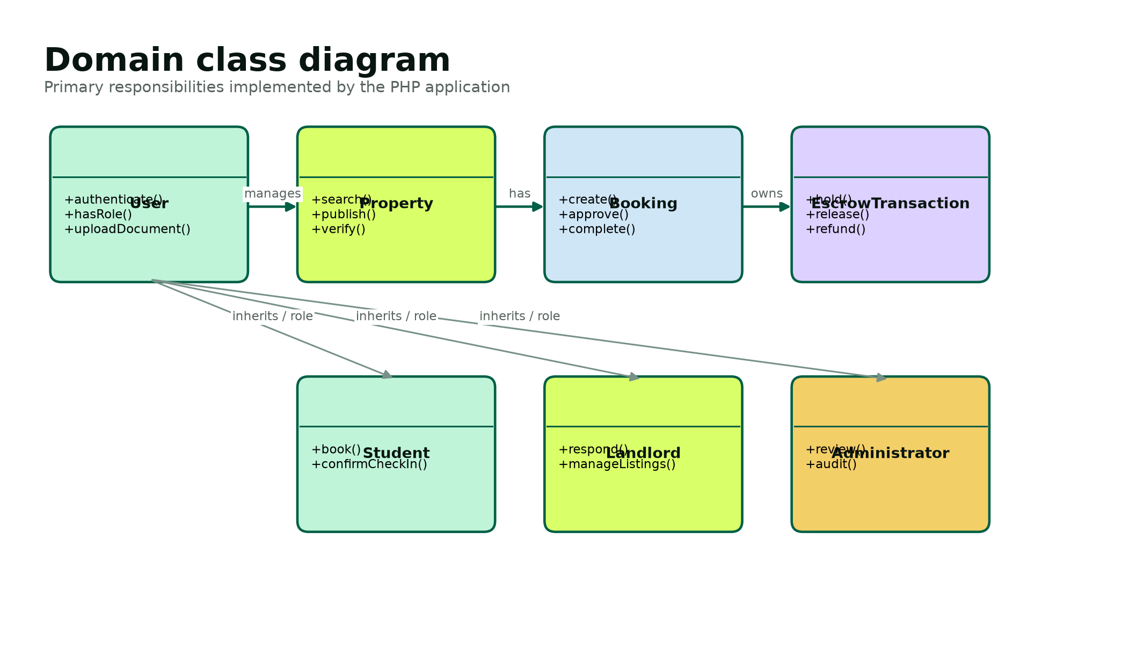
Figure 3. Domain classes and their responsibilities.
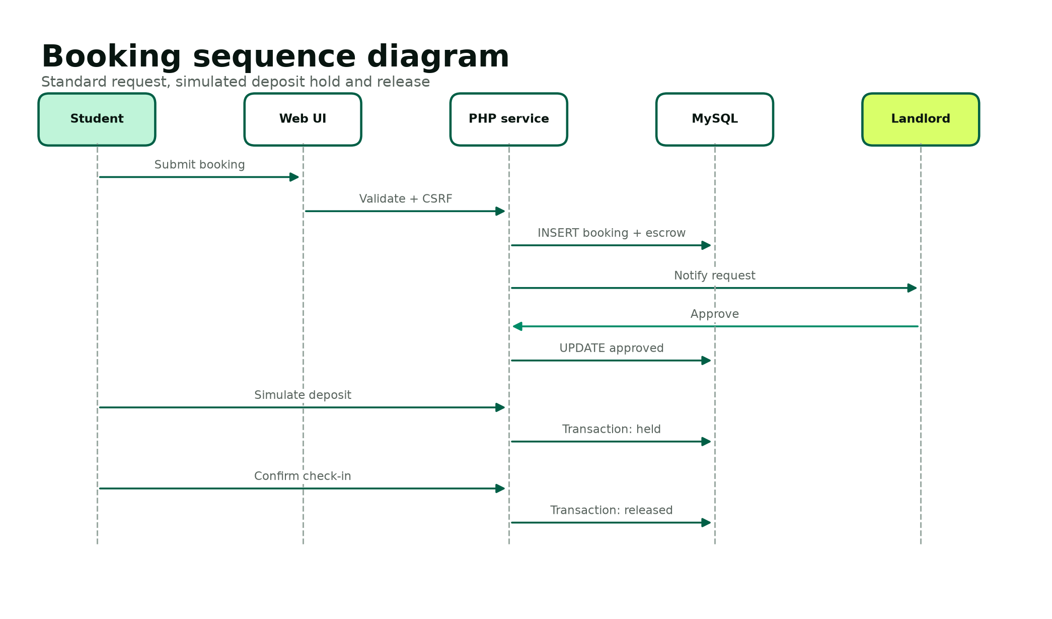
Figure 4. Booking request, approval and simulated escrow sequence.
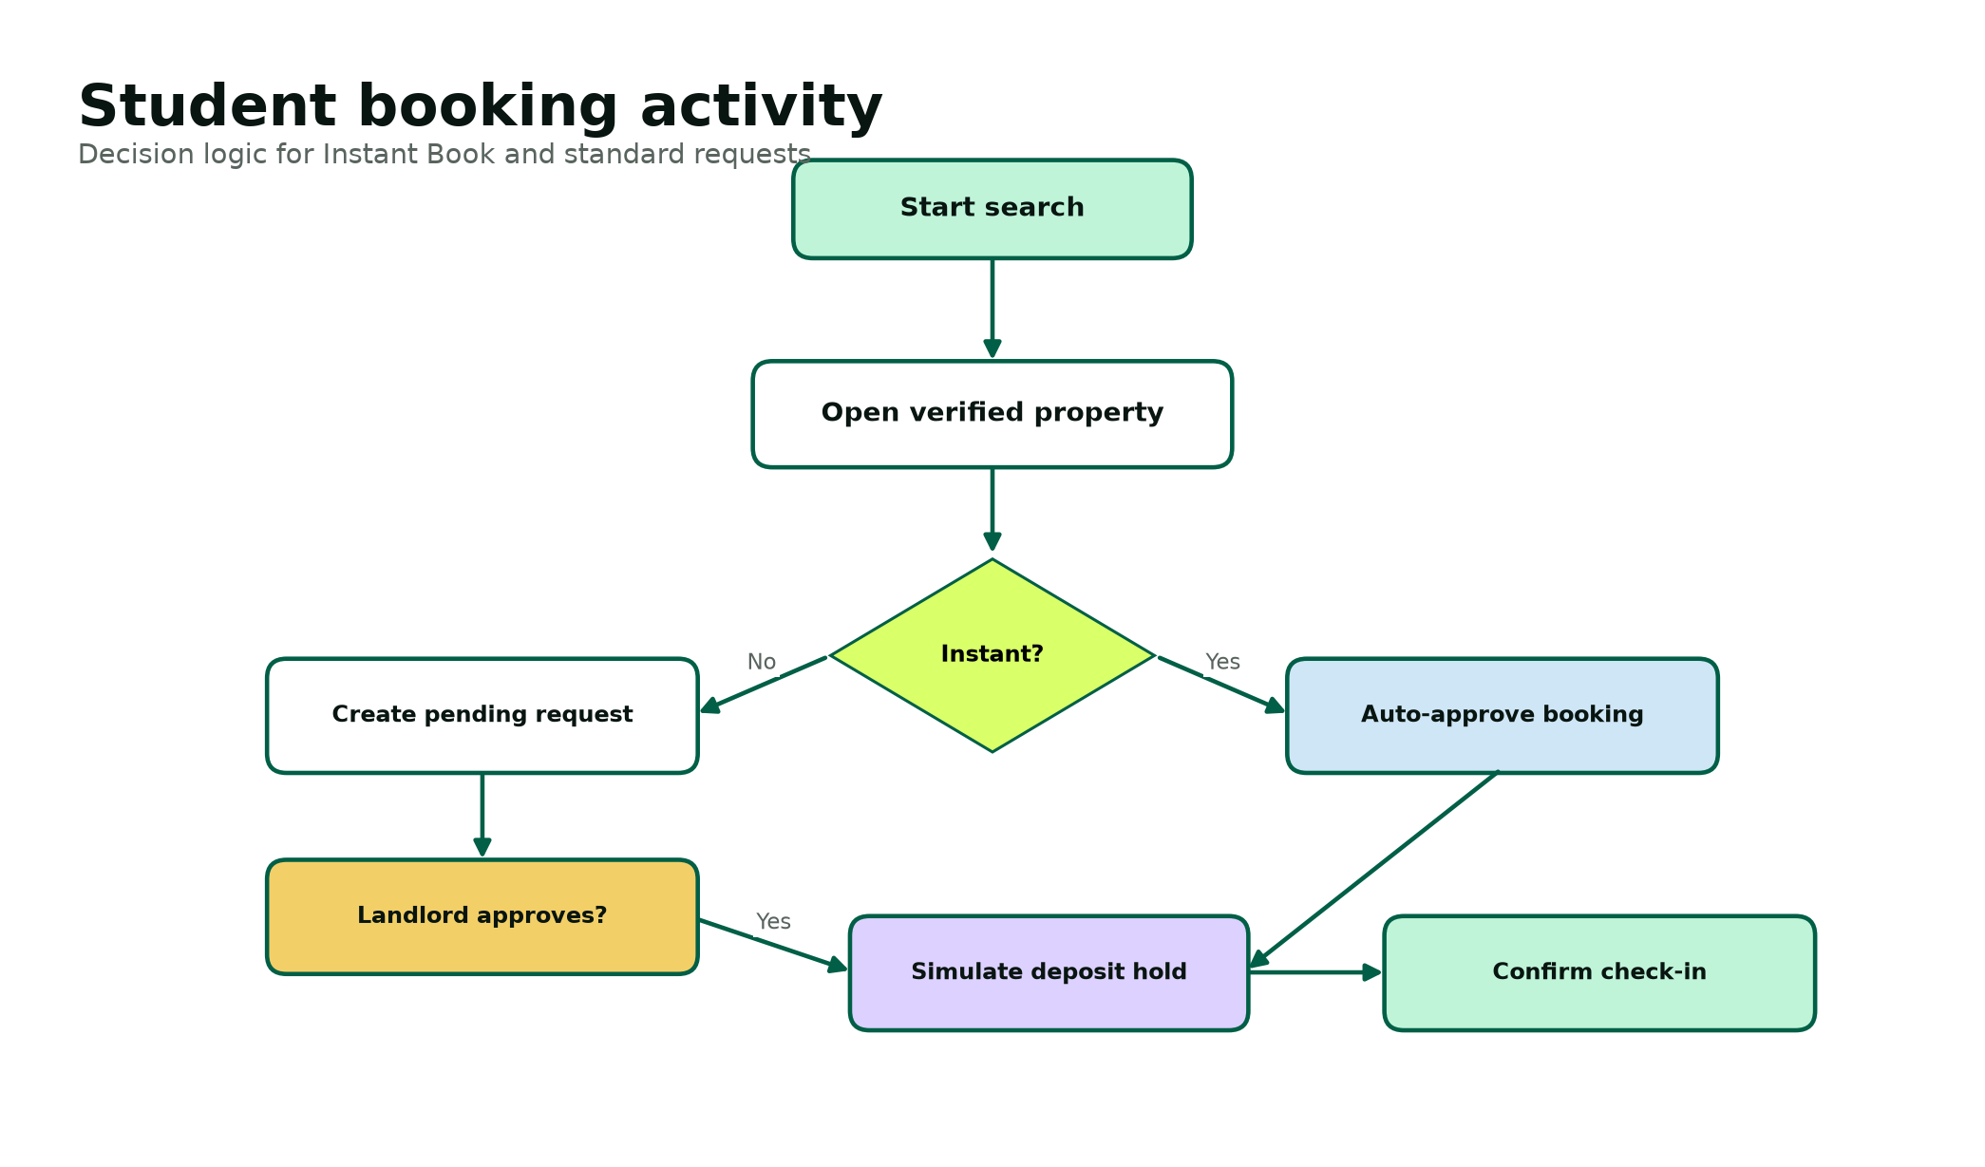
Figure 5. Student booking activity with Instant Book decision.
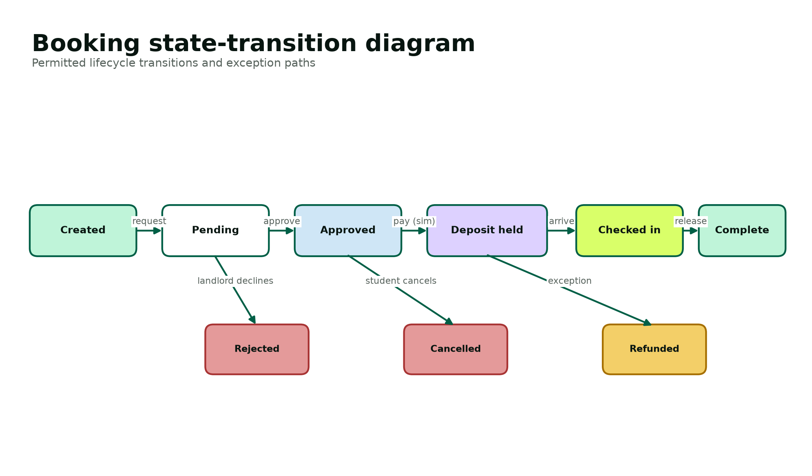
Figure 6. Permitted booking state transitions.
The state model is the design authority for booking actions. A standard request begins pending, while an Instant Book begins approved. Only pending requests can be approved or rejected. Only approved bookings can simulate a deposit hold. Only a held deposit can proceed to check-in and release. Cancellation or refund states are defined for production evolution, but the current UI implements the main successful path and landlord rejection. Every implemented transition is checked on the server and produces an audit event.

Physical and Database Design
The physical design uses seven InnoDB tables. Surrogate unsigned integer keys keep joins compact. Natural identifiers such as email, student number, escrow booking link and reference code receive unique constraints where appropriate. Foreign-key indexes support ownership and lifecycle queries. Search indexes combine property status, city and rent, while booking indexes combine actor and status. JSON is limited to amenities and generic audit details; core relationships and states remain typed relational columns.
Table 4. Database table dictionary
Table | Purpose | Primary relationships | Retention / sensitivity
users | Authentication identity and role | Parent of properties, bookings, documents and audit | Personal; retain only for active service and legal need.
properties | Accommodation listing, price, evidence flags and publication | Belongs to landlord; parent of media and bookings | Commercial/property data; review periodically.
property_media | Typed visual references and captions | Belongs to property | Remove with property.
bookings | Historical request, move-in, captured price and state | Belongs to property and student; parent of escrow | Transactional; retain for support/legal policy.
escrow_transactions | Simulated amount and lifecycle milestones | Exactly one per booking | Financial-like demo data; no real transaction details.
user_documents | Validated upload metadata and review outcome | Belongs to user; optionally reviewed by admin | Highly sensitive; demo only and delete after assessment.
audit_logs | Actor/action/entity/time evidence | Optional user reference | Security evidence; append-oriented and restricted.

Table 5. Selected field-level data dictionary
Entity.field | Type / size | Null? | Rule / meaning
users.id | BIGINT UNSIGNED | No | Primary key.
users.role | ENUM | No | student, landlord or admin.
users.email | VARCHAR(190) | No | Unique normalized login name.
users.student_number | VARCHAR(30) | Yes | Required for student role; unique when present.
users.password_hash | VARCHAR(255) | No | Self-contained password_hash output [7].
users.verified_at | DATETIME | Yes | Identity verification evidence time.
properties.landlord_id | BIGINT UNSIGNED | No | FK to landlord owner.
properties.monthly_rent | DECIMAL(10,2) | No | Positive current advertised rent.
properties.deposit_amount | DECIMAL(10,2) | No | Non-negative current deposit.
properties.instant_book | TINYINT(1) | No | Auto-approval eligibility.
properties.nsfas_accredited | TINYINT(1) | No | Reviewed accreditation flag.
properties.amenities_json | JSON | No | Display amenities array.
bookings.student_id | BIGINT UNSIGNED | No | FK to requesting student.
bookings.move_in_date | DATE | No | Requested date, today or later at entry.
bookings.monthly_rent | DECIMAL(10,2) | No | Historical rent captured at creation.
bookings.status | ENUM | No | Controlled lifecycle state.
bookings.response_deadline | DATETIME | Yes | Standard request creation + 12 hours.
escrow_transactions.booking_id | BIGINT UNSIGNED | No | Unique FK enforcing one-to-one.
escrow_transactions.status | ENUM | No | not_paid, held, released or refunded.
escrow_transactions.reference_code | VARCHAR(40) | Yes | Random simulator reference after hold.
user_documents.stored_name | VARCHAR(255) | No | Unique random name, not user supplied.
user_documents.mime_type | VARCHAR(100) | No | Server-inspected type.
audit_logs.action | VARCHAR(100) | No | Stable machine-readable event name.
audit_logs.details_json | JSON | Yes | Non-secret contextual details.

Normalization
First normal form is achieved by atomic user, property and booking columns; repeating property media records are stored separately. Second normal form is satisfied because non-key attributes depend on their complete table key. Third normal form removes landlord details from properties and student details from bookings: those facts depend on user identity and are joined through foreign keys. Escrow status is not stored as a property or user attribute because it depends on one booking. Historical rent and deposit are intentionally copied into a booking; this is a transaction snapshot, not accidental denormalization.
Table 6. Integrity and constraint design
Control | Database implementation | Application implementation
Entity integrity | Auto-increment primary key on every table. | IDs are parsed as integers and records must exist.
Referential integrity | Foreign keys between owners, properties, bookings, escrow, documents and audit users. | Ownership joins are included in protected actions.
Domain integrity | ENUM states, decimal types and CHECK constraints. | Allow-lists and state guards reject invalid values.
Uniqueness | Email, student number, escrow booking and stored filename constraints. | Duplicate registration returns a safe message.
Atomicity | InnoDB transactions. | Booking+escrow and hold/release updates commit or roll back together.
Confidentiality | Database remains outside public web assets. | Protected pages, escaped output and limited upload access.

Program Design and Pseudocode
The following pseudocode describes the highest-risk program paths. The delivered PHP uses the same validation, authorization, state and transaction order.
CREATE BOOKING
Require authenticated student
Validate CSRF token and property_id
Load verified, published property
Validate move-in date and message length
Begin database transaction
status := approved if Instant Book else pending
deadline := null if Instant Book else now + 12 hours
insert booking with captured rent and deposit
insert one escrow transaction with status not_paid
Commit transaction
Write audit event and redirect to student dashboard
SIMULATE DEPOSIT HOLD
Require authenticated student
Load booking + escrow WHERE booking.student_id = current_user.id
If booking.status != approved OR escrow.status != not_paid: reject
Begin transaction
update escrow to held, paid_at=now, random reference
update booking to deposit_held
Commit
Write audit event and show explicit no-real-funds message
CONFIRM CHECK-IN AND RELEASE
Require authenticated student and verify CSRF
Load owned booking and escrow
If booking.status != deposit_held OR escrow.status != held: reject
Begin transaction
update escrow to released and released_at=now
update booking to completed and checked_in_at=now
Commit
Write audit event and display completed reference
VALIDATE DOCUMENT UPLOAD
Require authenticated student and verify CSRF
Reject upload error or size > 5 MB
Inspect temporary file MIME using Fileinfo
Allow only PDF, JPEG or PNG
Generate random 40-character stored name and approved extension
Move file into protected uploads directory
Insert metadata with pending review state
Write audit event; never execute or expose original filename as a path

Interface Design
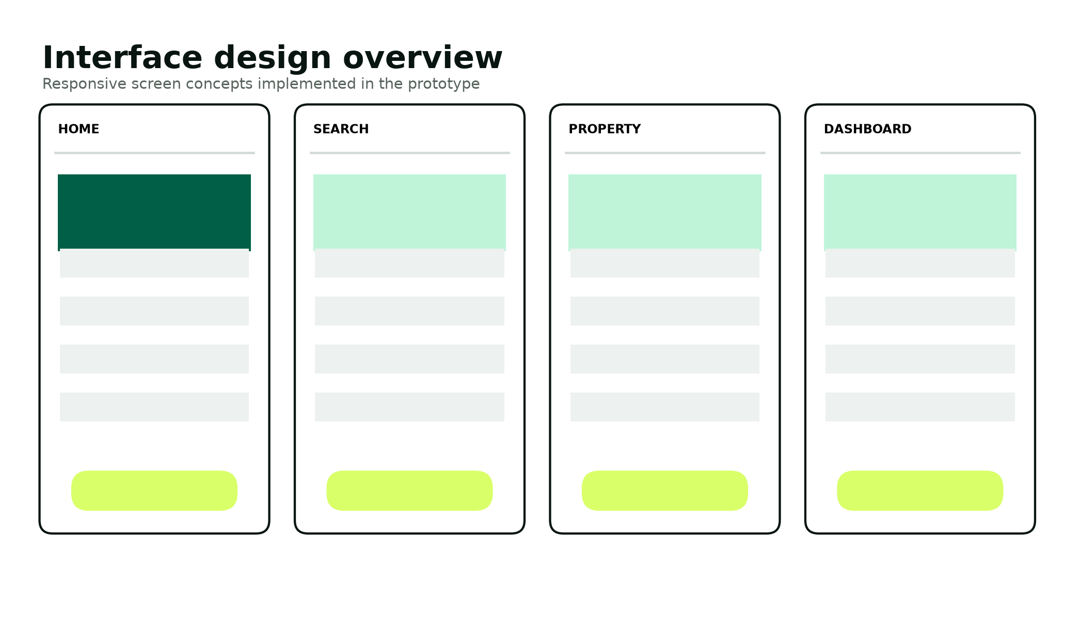
Figure 7. Interface design family implemented across the prototype.
Table 7. Screen design specification
Screen | Primary user task | Key controls / output | Validation and feedback
Home | Understand value and begin search | Hero search, trust pillars, featured listings and landlord call to action | Database setup state remains graceful.
Search | Narrow accommodation choices | Location, price, NSFAS and Instant Book filters | Empty state suggests widening filters.
Property | Make an informed decision | Visual proof, badges, rent, deposit, availability, amenities and booking action | Only published properties resolve.
Registration / login | Create or access role account | Labeled fields, role choice and password help | Server validation; generic login errors and throttling.
Student dashboard | Track and advance owned bookings | Status label, move-in facts, deposit/check-in actions and document upload | Actions appear only for valid states; server rechecks.
Landlord dashboard | Respond to owned property requests | Pending queue, message, approve/decline and metrics | Ownership join and pending-state guard.
Administrator dashboard | Review trust evidence | Verification queues, document decisions, totals and audit feed | Admin role gate and audited decisions.

Input Validation Design
Table 8. Input validation matrix
Input | Client constraint | Server constraint | Failure response
Email | email input type | FILTER_VALIDATE_EMAIL; normalized lowercase; unique | Specific registration duplicate, generic login error
Password | Help text and required field | At least 10 chars with upper, lower and number | Return policy message without echoing value
Phone | Required text | 9-20 approved phone characters | Return field-level message
Student number | Shown/required for student | Non-empty for student; unique when present | Reject registration
Property ID | Hidden/query integer | FILTER_VALIDATE_INT; load approved record | 404 or invalid action
Move-in date | date input with minimum today | Strict date parse and not before today | Return booking error
Booking message | maxlength 1000 | Trim and enforce <=1000 characters | Return booking error
Filter price | number min/step | Validated float and bound parameter | Ignore invalid optional filter
NSFAS upload | accept attribute | Upload error, <=5 MB, Fileinfo MIME allow-list | Safe error and no metadata insert
Action/state | Hidden action token | Allow-list, role, ownership and current state | 400/403 and no state change

Output and Report Design
All dynamic output is escaped before insertion into HTML. Dashboards report human-readable state labels while preserving machine-readable states in the database. The administrator dashboard provides operational totals and recent audit activity. The final report includes sample booking, property and verification outputs; production evolution can export filtered CSV or PDF reports without changing the transactional core.

Security and Backup Design
Table 9. Security control design
Threat / concern | Preventive control | Detective / recovery control
SQL injection | PDO prepared statements and allow-listed query structure [8]. | Database error logging without showing SQL to users.
Password disclosure | password_hash/password_verify; never store plaintext [7]. | Force reset and investigate account events in production.
Session theft/fixation | HttpOnly, SameSite, Secure-on-HTTPS cookies; ID rotation; OWASP-aligned session practice [9]. | Logout destruction, timeout policy and event monitoring.
CSRF | Random session token on state-changing forms; hash_equals verification. | Reject with 419 response and log repeated production failures.
Broken access control | Server role and ownership queries on every protected action. | Audit admin and escrow state changes.
XSS | Contextual htmlspecialchars output and restrictive Content Security Policy. | Security review and browser console monitoring.
Malicious upload | Size/MIME allow-list, random name, blocked executable extensions. | Quarantine/reject, review metadata and delete demo files.
Personal data over-collection | Purpose limitation, minimal prototype fields and demo-only documents [6]. | Retention review, deletion process and access audit.
Data loss | Versioned schema, regular encrypted backup and restore testing. | Recovery point/time objectives and incident runbook.
Fraudulent verification | Separate admin decision and visible timestamp. | Suspension, evidence preservation and audit review.

Table 10. Backup and recovery plan
Asset | Frequency | Method | Retention / restore test
MySQL production database | Daily full + frequent incremental/binlog | Encrypted automated backup to separate account/region | 30 daily, 12 monthly; quarterly restore test
Uploaded evidence | Daily encrypted object replication | Versioned private object storage | Policy-driven; delete when purpose ends
Application code | Every accepted change | Version-control remote plus release archive | Retain tagged academic and production releases
Configuration secrets | On change | Managed secret store; never in repository | Versioned access policy; rotation drill
Academic local demo | Before presentation and submission | Zip package plus SQL schema/seed and offline deck | Keep assessment copy; reset demo after use

Design Test Cases
Test cases are designed before implementation completion so acceptance is based on requirements rather than on whatever the code happens to do. Each case identifies preconditions, input/action, expected result and evidence. The complete execution register appears in Phase 5.
Table 11. Representative design-stage test cases
ID | Requirement | Scenario | Expected result
TC-D01 | FR-03 | Sign in with correct active demo account. | Session ID rotates and correct role dashboard opens.
TC-D02 | FR-05 | Search while an unverified draft property exists. | Draft property never appears.
TC-D03 | FR-11 | Create standard request at a known time. | Pending booking stores deadline exactly 12 hours later.
TC-D04 | FR-12 | Book an eligible Instant Book listing. | Booking begins approved and escrow begins not_paid.
TC-D05 | FR-14 | Landlord changes booking ID to another owner. | No record is returned and action fails.
TC-D06 | FR-18 | Try deposit hold before approval. | State remains unchanged.
TC-D07 | FR-19 | Confirm check-in after valid hold. | Booking completes and escrow releases in one transaction.
TC-D08 | FR-21 | Upload a renamed executable file. | MIME/type validation rejects the file.
TC-D09 | FR-23 | Student posts administrator verification action. | Role gate returns forbidden; no record changes.
TC-D10 | NFR-03 | Submit form with missing/incorrect CSRF token. | 419 response and no state change.

References
[6] Republic of South Africa. Protection of Personal Information Act 4 of 2013. https://www.justice.gov.za/legislation/acts/2013-004.pdf
[7] PHP Documentation. password_hash and password_verify guidance. https://www.php.net/manual/en/function.password-hash.php
[8] PHP Documentation. PDO::prepare and parameter binding. https://www.php.net/manual/en/pdo.prepare.php
[9] OWASP Cheat Sheet Series. Authentication and Session Management guidance. https://cheatsheetseries.owasp.org/cheatsheets/Authentication_Cheat_Sheet.html
Project source: IT PROJECT GUIDELINES SEMESTER 2 2026.pdf and the original Group 55 Phase 1 / EMERGEX pitch documents.

